**Week 7**

**13.ReactJS – HOL**

**FILE STRUCTURE  
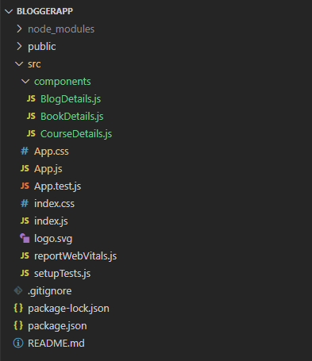  
  
CODE**

*C:\Users\User\Desktop\bloggerapp\src\App.js*

import React from 'react';

import CourseDetails from './components/CourseDetails';

import BookDetails from './components/BookDetails';

import BlogDetails from './components/BlogDetails';

import './App.css';

function App() {

  const books = [

    { id: 101, bname: 'Master React', price: 670 },

    { id: 102, bname: 'Deep Dive into Angular 11', price: 800 },

    { id: 102, bname: 'Mango Essentials', price: 450 },

  ];

  const showBlog = true;

  const enrolledInCourse = true;

  return (

    <div className="app-container">

      <div className="section">

        <CourseDetails enrolled={enrolledInCourse} />

      </div>

      <div className="divider" />

      <div className="section">

        <BookDetails books={books} />

      </div>

      <div className="divider" />

      <div className="section">

        <BlogDetails show={showBlog} />

      </div>

    </div>

  );

}

export default App;

*C:\Users\User\Desktop\bloggerapp\src\components\CourseDetails.js*

import React from 'react';

function CourseDetails({ enrolled }) {

  if (!enrolled) {

    return <p>No courses enrolled</p>;

  }

  return (

    <div className="st1">

      <h1>Course Details</h1>

      <h2>Angular</h2>

      <h4>4/5/2021</h4>

      <h2>React</h2>

      <h4>6/3/20201</h4>

    </div>

  );

}

export default CourseDetails;

*C:\Users\User\Desktop\bloggerapp\src\components\BookDetails.js*

import React from 'react';

function BookDetails({ books }) {

  return (

    <div className="st2">

      <h1>Book Details</h1>

      {

        books.length > 0 ? (

          <ul>

            {

              books.map((book) => (

                <div key={book.id}>

                  <h3>{book.bname}</h3>

                  <h4>{book.price}</h4>

                </div>

              ))

            }

          </ul>

        ) : (

          <p>No books available</p>

        )

      }

    </div>

  );

}

export default BookDetails;

*C:\Users\User\Desktop\bloggerapp\src\components\BlogDetails.js*

import React from 'react';

function BlogDetails({ show }) {

  return (

    <div className="v1">

      <h1>Blog Details</h1>

      <h2>React Learning</h2>

      <h4>Stephen Biz</h4>

      {show ? <p>Welcome to learning React!</p> : null}

      <h2>Installation</h2>

      <h4>Schewzdenier</h4>

      {show && <p>You can install React from npm.</p>}

    </div>

  );

}

export default BlogDetails;

*C:\Users\User\Desktop\bloggerapp\src\App.css*

.app-container {

  display: flex;

  justify-content: center;

  align-items: flex-start;

  padding: 50px;

  gap: 10px;

}

.section {

  flex: 1;

  padding: 10px;

}

.divider {

  width: 4px;

  background-color: green;

  height: 100%;

  min-height: 400px;

  margin: 0 10px;

}

**OUTPUT**  
  
